Deep Learning Based Spam Email Classification

- Introduction
This project focuses on classifying SMS messages as Spam or Ham using Deep Learning techniques. The aim is to build an intelligent neural network model capable of automatically detecting spam messages.
- Objective
The objective of this project is to implement a Deep Learning model for spam message classification using TensorFlow and Keras.
- Dataset
The SMS Spam Collection Dataset from Kaggle was used in this project. The dataset contains labeled SMS messages categorized as spam or ham.
- Technologies Used
Technologies used in the project are
• Python
• TensorFlow
• Keras
• Pandas
• NumPy
• Matplotlib
- Deep Learning Model
An LSTM (Long Short-Term Memory) neural network was used for text classification. Tokenization and padding techniques were applied to preprocess text data before training the model.
- Methodology
The methodologies used in this project are
1. Dataset preprocessing was performed.
2. Text messages were tokenized into numerical sequences.
3. Padding was applied to maintain equal sequence length.
4. The dataset was divided into training and testing sets.
5. An LSTM-based neural network was trained using TensorFlow/Keras.
6. Model performance was evaluated using accuracy and loss metrics.

- Results
Results are as follows
Test accuracy: 0.98
- Training Graph
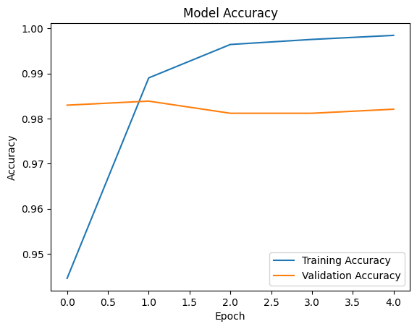
- Conclusion

The Deep Learning model successfully classified spam and ham messages with high accuracy. This project demonstrates the practical application of LSTM neural networks in Natural Language Processing tasks.
- GitHub Repository Link
https://github.com/muskisingh22/deep-learning-spam-classifier

